ELECTORAL COMMISSION
TE KAITIAKI TAKE KŌWHIRI
ACCESS 2020
DISABILITY STRATEGY
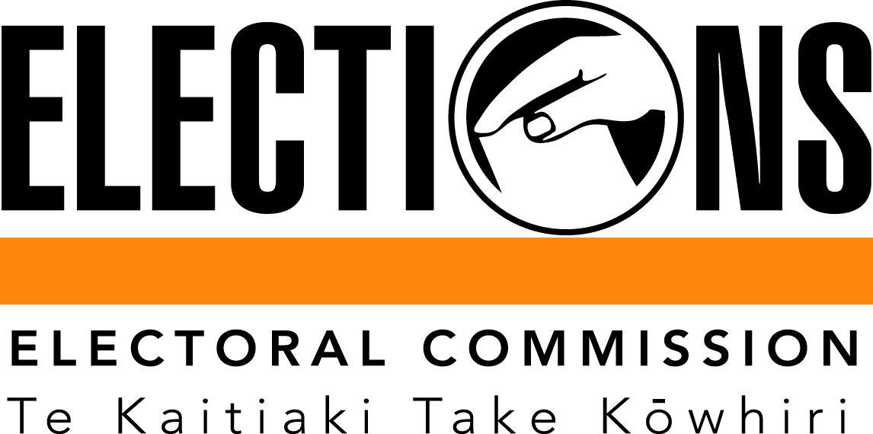
July 2013

1. Introduction

Since 2005, the Electoral Commission has been working to improve access to electoral events for disabled New Zealanders.
Action plans were developed for the 2005, 2008 and 2011 general elections that detailed new and continuing initiatives to improve accessibility of venues and information. These initiatives were developed and implemented in consultation with the disability sector.
The Access 2020 disability strategy takes the improvements made over the past three electoral cycles and embeds them into a longer-term framework, through which the Commission aims to identify and reduce barriers that disabled people may encounter when enrolling and voting at elections.
The purpose of the strategy is to set out a framework through which the Commission will develop policies and processes that support section 12 of the New Zealand Bill of Rights Act 1990 and the New Zealand Disability Strategy.

2. Goal

The Commission’s goal is that by the year 2020, all eligible New Zealanders, regardless of disability, are able to fully participate in parliamentary elections.

3. Objectives

Access 2020 has three objectives, that by 2020:
- disabled voters will be able to cast an independent and secret ballot in parliamentary elections
- disabled New Zealanders can access the Electoral Commission’s services and information in ways that meet their needs
- research and relationship programmes provide ongoing opportunities for improvement

4. Background

Around one in five New Zealanders has a disability. This equates to 660,300 people. That means approximately 20 percent of the eligible voting population live with an impairment that may mean they face additional barriers to take part in the electoral process.
Supporting disabled people and their families, whānau and caregivers to participate at elections is the focus of the Commission’s disability strategy. We want to continue our work to identify and reduce barriers that disabled people may encounter when enrolling and voting at elections.
The Commission’s statutory objective is to administer the electoral system impartially, efficiently, effectively, and in a way that –
- Facilitates participation in parliamentary democracy; and
- Promotes understanding of the electoral system; and
- Maintains confidence in the administration of the electoral system.
The Commission wants New Zealanders to actively choose to enrol and vote, and have the information and resources they need to make it easy.
We want to achieve our vision, that New Zealanders trust, value and take part in parliamentary elections.
Facilitating participation is the core of our disability strategy.
We know that disabled people value their right to take part in parliamentary elections. We know that it is easy for most New Zealanders to enrol and vote, but those with disabilities face additional barriers.
The Commission’s priority, therefore, is to reduce barriers to participation by developing programmes and processes that enable New Zealanders living with an impairment to fully access our services.
The Commission supports the vision of the New Zealand Disability Strategy – where people with impairments can say that they live in a society that highly values our lives and continually enhances our full participation.
The Commission is also committed to contributing, where appropriate, to the vision outlined in the UN Convention on the Rights of Persons with Disabilities to achieve participation in political and public life.

5. Current Situation

Many disabled people are currently able to vote independently and in secret. At the 2011 general election 65% of disabled voters were able to vote unassisted and 17% required the assistance of election day staff.
At the 2011 general election most disabled voters (75%) were either ‘happy’ or ‘very happy’ with the voting facilities and 82% rated how well electoral staff provided for the needs of the disabled as 4 or 5 out of 5.
80% of disabled voters with a disability went to a voting place on election day, 18% went to an advance voting facility, 1% voted from a hospital or care home, and 1% voted using papers delivered by mail.
Although disabled voters tended to spend longer in the voting place, 97% said the time spent ‘was about right’.
The main overall reasons for not voting at the 2011 general election were health reasons (25%), the voting place being too far away or not having transport (24%), ‘cannot be bothered voting’ (8%), ‘makes no difference who the government is’ (8%) and ‘my vote doesn’t make a difference’ (8%).

6. The Strategy

The Electoral Commission’s disability strategy is made up of three elements, all of which support our long term goal of enabling full participation for all New Zealanders, regardless of impairment:
- Promote enrolment processes and voting channels that enable all New Zealanders to participate in parliamentary elections, and seek legislation and funding to allow this.
- Provide information and resources in accessible formats
- Maintain strong relationships with the disability sector

Objective 1: By 2020, disabled voters will be able to cast an independent and secret ballot in parliamentary elections.
The Commission recognises that new technologies may offer opportunities to improve access to enrolment and voting services for all New Zealanders.
The Commission will continue to monitor overseas use of assistive technologies that offer opportunities to improve accessibility to the voting process.
The Commission will, continue to promote enrolment processes and voting channels that enable all New Zealanders to fully participate in parliamentary elections and will seek funding and legislation to allow this. This will include the use of voting technologies that assists voters to participate in the electoral process independently and in secret.
Objective for 2014: Telephone Dictation Voting
The Commission will promote legislative change in 2014 to enable telephone dictation voting for voters who are blind or visually impaired or have another disability that means they are unable to vote independently and in secret. The Government has indicated its support for the required amendments to the regulations. In the meantime, the Commission is looking at the feasibility of when we may be able to begin providing this service and we hope that it can be made available in time for the 2014 general election. This initiative would enable some disabled voters to vote in secret, and provide a case study for potential wider usage at the 2017 general election.
Voters who are eligible for this service would need to pre-register and vote during the advance voting period. This would help ensure that voters are not disenfranchised because they are not able to access dictation voting at the last minute on election day. A person who has not registered would be able to vote using the existing methods available.
The regulatory change required to allow dictation voting is due to go through in early 2014, and the trial would run for the 2014 general election, resources allowing.
Objective for 2017: Improved accessibility to the enrolment process
We will continually seek to simplify and improve accessibility to enrolment systems and processes for disabled people.
We will continue to receive feedback on how the enrolment form and process can be improved before considering what changes might help reduce barriers. Any changes are likely to be implemented after the 2014 general election is completed.

Objective for 2020: Online voting
The Electoral Commission is continuing to monitor the results of overseas electronic voting initiatives, particularly work being undertaken by Australian electoral authorities to determine the potential for an Australasian online voting process. At each opportunity, the Commission will seek the legislative change and resourcing required to enable online voting in New Zealand.
Objective 2: Disabled New Zealanders can access the Electoral Commission’s services and information in ways that meet their needs
The Electoral Act and associated regulations have various provisions to assist disabled people and services provided by the Electoral Commission must comply with the requirements of the Act. Provisions include:
- A person with a physical disability may have someone with a Power of Attorney or a registered elector complete and sign the enrolment form on their behalf.
- A person who lacks the capacity to understand the decision to register as an elector may be enrolled by someone else on behalf of that person.
- There must be voting facilities in hospitals and similar institutions.
- At least 12 voting places in each electorate must have access suitable for the physically disabled. The Commission’s objective is that as many voting places as possible are fully accessible.
- Election staff or a person nominated by a voter may read out the names of parties and candidates to the voter.
- Election staff or a person nominated by the voter may assist marking the voter’s voting paper according to the voter’s instructions.

The Commission also recognises the need to ensure materials about enrolling and voting are appropriate, accessible and easy to understand and use. This is essential to ensure effective and full participation of disabled people in the electoral process.
We will focus on making more information available in accessible formats and focus on increasing resources that are available in New Zealand Sign Language and Plain English. We will also continue to provide facilitated programmes for those with learning and cognitive disabilities.

Objective for 2014: Refine and improve accessible services, information and resources
Access to voting services
- Provide facility for online enrolment and updating of enrolment details.
- Capacity for others to apply for enrolment on a disabled person’s behalf.
- Ensure as many voting places as possible are fully physically accessible. Unless there is no alternative, all advance voting places will be fully accessible.
- Advertise accessible advance voting places and voting places, including car parks, with the International Symbol of Access.
- Table-top voting available at every voting place.
- All known rest homes and hospitals visited before election day to provide an advance voting service.
- A friend, family member or electoral official may help to read or mark a ballot paper at the voter’s direction. Voters may also request the names of parties and candidates to be read aloud and say their choice aloud.
- Returning Officers can post voting papers to voters or send them via an agent on the voter’s request.
- Disability awareness training will be delivered to all Returning Officers and Election Day staff.
- The Electoral Commission’s recruitment policy provides that election staff should reflect the community. All advertisements for election staff state that applications from people with disabilities are welcome.

Access to information and resources
- The Electoral Commission website www.elections.org.nz supports the Government’s accessibility guidelines.
- A DVD-based learning and facilitation guide for carers and people with learning difficulties. This DVD and guide introduces concepts around voting, how to enrol and how to vote.
- Plain English videos and printed resources, all available online as well as in hard copy.
- A Plain English DVD that introduces concepts around voting, how to enrol and how to vote, captioned and with optional in-screen NZSL translation.
- NZSL versions of all general election web content available online.
- Materials in accessible formats for voters with vision impairments through the Blind Foundation.

Objective 3: Research and relationship programmes provide ongoing opportunities for improvement
The relationship between the Electoral Commission and the disability sector is crucial to the evaluation and future improvement of services to disabled voters, and the Commission’s work with the disability sector carries across the duration of each electoral cycle.
After each election the Electoral Commission carries out a substantial review, which includes post-election surveying of voters and non-voters with a disability. The Commission also conducts a survey of those agencies we worked with to create specific resources.

In the lead-up to each election, we consult with the disability sector on potential process and resource improvements. After the consultation process, the Commission works with sector providers to develop targeted resources (as far as budget, legislation and practicalities allow).

The Commission will continue to review its services to disabled voters after each election, and consult with the disability sector on future improvements. We will monitor best practice approaches and future improvements through research, both internally generated and externally produced.

The Commission aims to be seen a leader in providing equitable voter services, championing the importance of accessible information and services.
Objective for 2014: Establish a Disability Advisory Group
The Commission will establish a Disability Advisory Group, which will include representatives from disability organisations and relevant government agencies, to strengthen relationships and to inform the Commission’s approach on matters of accessibility.
This advisory group will provide guidance, advice and testing of products, services and research targeting disabled voters.

7. Evaluation and Reporting
The Commission continually monitors its service delivery. It reports after each general election to the House of Representatives on the administration of that election. The Commission’s reporting on electoral events includes details about the information and services provided to disabled voters. This information also feeds into the improvement programme for the next election.
The Commission contributes to the Human Rights Commission’s reporting on the delivery of the New Zealand Disability Strategy, and its contribution to the monitoring mechanism established under the United Nations Convention of the Rights of Persons with Disabilities, which in Article 29 calls for independent and secret voting by 2020.
The New Zealand Disability Strategy contains 15 objectives. The Electoral Commission’s Access 2020 Strategy targets specific action points within a number of these objectives. They are:
Objective 6: Foster an aware and responsive public service.
6.3 Ensure all government agencies treat disabled people with dignity and respect.
6.4 Improve the quality of information available, including where to go for more information, the services available and how to access them.
6.5 Make all information and communication methods offered to the general public available in formats appropriate to the different needs of disabled people.
6.6 Ensure the locations and buildings of all government agencies and public services are accessible.
Objective 10: Collect and use relevant information about disabled people and disability issues.
10.2 Collect relevant and useful information about disability through all relevant surveys to inform the research programme.
10.5 Make disability research information available to disabled people in culturally appropriate and accessible formats.
Progress against these objectives will form the core of the evaluation and measurement of the delivery of the Access 2020 Strategy.

New Zealand Disability Survey 2006

