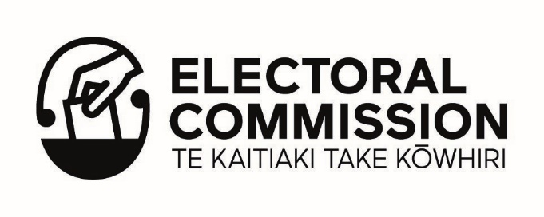
Declaration

I declare that:

- I am applying to the Election Access Fund as a person with a disability, being a long-term (lasting or expected to last 6 months or more) physical, mental, intellectual or sensory impairment which, in interaction with various barriers may hinder my full and effective participation in society on an equal basis with others.

- I am seeking to be a candidate, or to be selected as a candidate, in a parliamentary general election or by-election and I face barriers to doing so, as a consequence of my disability, and which non-disabled individuals do not face.

- I understand that I must not seek funding from the Election Access Fund for specific costs already funded by another government agency

- I am or will be 18 on or before nominations day (if known) or by 12 November 2023 (the day the current Parliament expires)

- The information I have provided is true and correct to the best of my knowledge.

- I understand that I may be asked for further information to support my application if necessary.

- I understand that this application will be reviewed by the Applications Panel with my name and any political party names removed.

- I understand that submitting this application does not guarantee that part or all of the funding I have applied for will be approved.

Name:

Signature:

Date:

Please note: Please sign electronically or by hand. We cannot accept typed signatures or digital certificates. If you are signing this as part of your online application, you will need to upload it at the end of your application process.

